**Project Specifications SOPFIM**

# Web tracking programs

Tool for decision support to monitor the Service pulvérisationspour statements and Operations Branch

The Society for the Protection of forests against insects and diseases (SOPFIM) is mandated to perform various welfare programs. This project is tracking a program against the spruce budworm (SBW), but it could apply to different insects.

For the next project, the Directorate of Forestry and Environment, in collaboration with the statements defined forest areas susceptible and vulnerable to spruce budworm. These sectors are defined according to specific criteria applied by the Department of Geomatics Ecoforest on each stand, such as gasoline, volume, age, etc.. From this thematic groupings are meant to create areas eligible for protection against TBE. Annually, monitoring is done to remove the sector disruptions natural or human-type (fire, cutting, etc..). Service records has established a network of sample plots within these areas eligible for protection, to monitor the evolution of TBE. During an epidemic, a more refined network is located in the territory concerned. Based on the results of these surveys, which give the number of larvae per branch, and aerial surveys of the damage done annually by the Department of Natural Resources and Wildlife (MRNF), a new area is bounded by taking into account environmental zones sensitive (drinking water, ecological reserve, salmon river, etc..). It is in this new area a prescription treatment is prescribed. Furthermore, this requirement defines the product to use and the number of applications to perform at a developmental stage of the insect specific.

From this area limitation Operations Directorate, in collaboration with the Department of Geomatics create blocks to be treated and spray missions under different operational criteria. To do this, we take into account sensitive environmental areas, from satellite imagery, topography and 3D models. The latter facilitates the design of the block and the direction of flight lines. The Operations Branch coordinates the aerial part, which is detailed later in the document.

Currently, SOPFIM is to prepare the intervention program for the 2010 season. Previous years, the Department of Geomatics preparing projects on control programs, both for the service records for the Operations Directorate. Was produced for teams outside the office, projects on ArcPad and ArcView Desktop, Carry on Map and also in Acrobat (pdf). By cons, people were leaving the field with paper maps and followed for some visual tracking was done with wall maps they did evolve during the program manually.

With the purchase of ArcGIS Server, we deploy projects on the web for that monitoring is interactive for both user groups.

Moreover, these two user groups must continually exchange information to do their monitoring when they are in places far from each other. So Service records must show the blocks ready to be processed and the operations manager must, on his side, showing what has been processed.

Rating: If there is an offline period, records managers and operations communicate by radio or telephone to transmit the information to be captured. Users then complete the survey form operations, in order to have updated information in the visual processing carried out. When reconnecting, users will update records only the information they own.

The operations manager will have the same choice for survey data. The side of operations, there could be a short form or the ability to capture only part of the form to update their treatment, this only when they are offline.

Sample form for entering messages Opening:

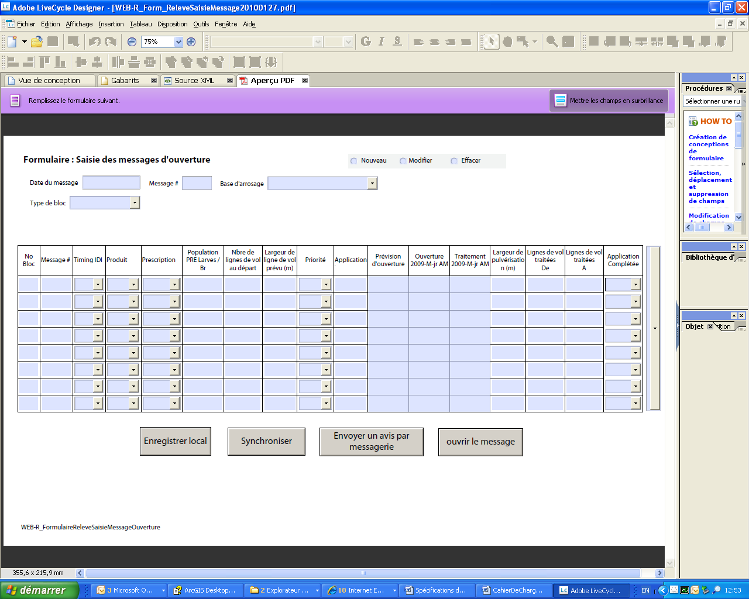

1. Save locally can be done regularly without causing changes to the server.
2. For the Sync button, a confirmation request. Question: Entering the Post # 12 a happy ending? Choice: Confirmed or Cancelled to return to message # 12.
3. To view, he can click the Open button on the message, if there are things to add, he continued input at the form level. If after viewing the message is complete, then they can click the Synchronize button.
4. By clicking the Send Message button, an email is sent to those concerned to advise them that the opening message is available and the visual processing priorities.

**Edit:** The message can be changed only when it has not been saved to the server, otherwise it becomes a new message. The message will have the same date, but bear a different number if the message is edited in one day.

**Delete:** The message can be erased only when it has not been synchronized to the server, otherwise you need to do a new message, even if the same date. Add confirmation before deleting.

**Opening prediction:** Input via a schedule or manually by the responsible field surveys YYYY / MM / DD. The date is an estimate and may change.

**Opening:** Input via a schedule or manually by the responsible statements. Date field: YYYY / MM / DD. PM. Also put the time represented in this format AM or PM after the date. This indicates that the block is open for the treatment of morning or evening.

**Spraying:** Date of the treatments (YYYY / MM / DD. AM). Information to be displayed when the operations have seized the table Tracking spray.

**Number of flight lines:** Seizure made before the spraying period. Is the number of flight lines for spray missions to 30 m for this block.

**Of rows processed:** Information to be displayed when the operations have seized the table Tracking spray. The one entered here will be treated Lines

Ex: The rows processed: 1 to 12.

**Lines processed:** Information to be displayed when the operations have seized the table Tracking spray. The 12 will be entered in this field Lines processed:

Ex: The rows processed: 1 to 12.

**PourcentageProg:** This field will be filled by synchronizing with Follow the spray table. It represents the percentage of spraying conducted on the entire program for the season. For details, see section Monitoring of operations.

**Save Locally**: Click the Save button can be done locally on a regular basis without causing changes to the server.

**Synchronize:** For the Sync button you will have to answer a question before we go any further. Question: Entering the Post # 12 a happy ending?

Choice: Confirmed records information to the server.

**Canceled** to return to message # 12.

**Send a notice by mail:** By clicking on this button, an email is sent to those concerned to advise them that the opening message is available and the visual openings and block their processing priorities.

**Open the message:** To view, he can click on the button to open the message, if there are things to add, he continued input at the form level. If after viewing the message is complete, then they can click the Synchronize button. This will open in a report the current message.

**Form before the opening message**: updates the table and the message of openness

## Buffer layer 30 m

## The layer of operational block

The experimental block layer

The block layer strategy

**Table and the message of openness**: Sample Table TableSuiviMessageOuverture.xls see Excel file, an example of the message table for opening statements and another for operations.

**Report of the opening message** :

**Opening Message:**

The opening message is a report generated from the table Tracking opening message that contains the history of daily monitoring and forecasting process for the season.

The message is generated once a day 14 hours before the service records

An example of a message of openness: the report was generated from Excel via the option and dynamic pivot table. The table is connected on the table and the message of openness that is in SQL Server 2005. We would like to know if it's possible to work that way, because there would be no programming to be done to generate the report.

Found in the report the same fields that were entered in the form of the Seized opening message and the table followed by the opening message: some have different names from one table to another. (This is a preliminary version, all will be adjusted.)

**Open the existing message # forecast opening**

Simulation of Post # 14 for the base of Baie Comeau

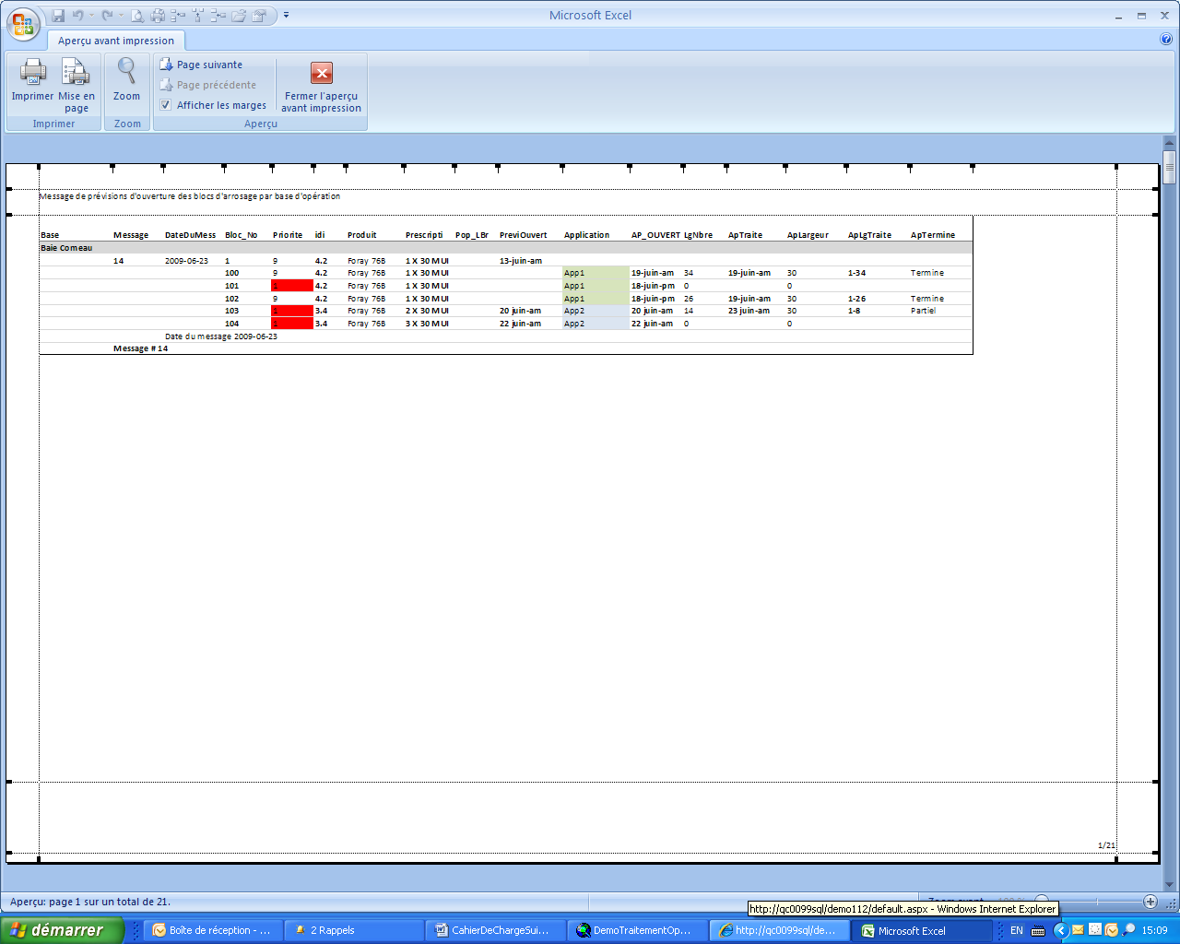

**0**

Sample selection may be made:

By block and no message or message date: Block 103 and messages 6-16

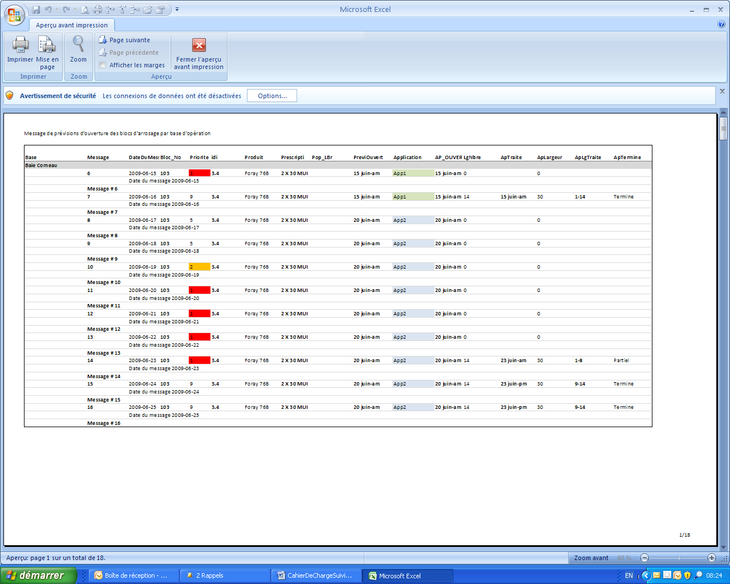

14

14

14



14

14

14

Simulation:

Priority application, Details

A 1Priorité 1 = High Priority, is an open implementation for this block.

2 A Priority 2 = Medium Priority, is an open implementation for this block.

3 A Priority 3 = Low priority, is an open implementation for this block.

5 2 Priority 5, an application is complete, waiting for another application.

A 2 Priority 1, Application 2 is open for this block. (Use 1 or 6 for app.2)

2 2 Priority 2, Application 2 is open for this block. (Use 1 or 7 app. 2)

3 2 Priority 3, application 2 is open for this block. (Use 1 or 8 for app. 2)

A 3 Priority 1, Application 2 is open for this block.

2 3 Priority 2, Application 2 is open for this block.

3 3 Priority 3, application 2 is open for this block.

9 A Priority 9, an implementation is completed or terminated or the block is closed or canceled.

9 2 Priority 9, 1 and 2 applications are completed or terminated or the block is closed or canceled.

9 3Priorité 9, applications 1, 2 and 3 are completed or terminated or the block is closed or canceled.

We can see: The message 6

Priority: The priority of a watering

Ap_Ouvert: The opening date for application 1

Post 7

Priority: The priority of treatment to 5, for a complete implementation, but there is still another.

Ap_Ouvert: Date of application processing 2

LgNbre: Number of lines for this block starting = 14

Fields that are filled via the Table followed spraying

ApTraité: Date yyyy / mm / dd AM / PM

ApLgTraité: Lines addressed - to

ApTerminé: "Done" to change to "Completed"

Message 8

Priority: The priority of treatment to 5, for a complete implementation, but there is still another.

Ap_Ouvert: Date of application processing 2

LgNbre: number of lines for this block starting at 14 =

ApLgTraite: The rows processed

ApTerminé: Completed

Post 9

Priority: The priority of treatment to 5, for a complete implementation, but there is still another.

Ap_Ouvert: Date of application processing 2

LgNbre: Number of lines for this block starting = 14

ApLgTraite: The rows processed

ApTerminé: Completed

Message 10

Priority: The priority of treatment to 2, for two purposes.

Ap_Ouvert: Date of application processing 2

LgNbre: Number of lines for this block starting = 14

ApLargeur: The width of processing performed

ApLgTraite: The rows processed

ApTerminé: Completed

Post 11

Priority: The priority of treatment 1, application 2

Ap_Ouvert: Date of application processing 2

LgNbre: Number of lines for this block starting = 14

ApLargeur: The width of processing performed

ApLgTraite: The rows processed

ApTerminé: Completed

Post 12

Priority: The priority of treatment 1, application 2

Ap_Ouvert: Date of application processing 2

LgNbre: Number of lines for this block starting = 14

ApLargeur: The width of processing performed

ApLgTraite: The rows processed

ApTerminé: Completed

Post 13

Priority: The priority of treatment 1, application 2

Ap_Ouvert: Date of application processing 2

LgNbre: Number of lines for this block starting = 14

ApLargeur: The width of processing performed

ApLgTraite: Lines 1-8 treated

ApTerminé: Partial

Post 14

Priority: The priority of treatment to 9, for application 2

Ap_Ouvert: Date of application processing 2

LgNbre: Number of lines for this block starting = 14

Fields that are filled via the Table followed spraying

ApTraité: Date yyyy / mm / dd AM / PM

ApLgTraite: Lines addressed - to

ApTerminé: "Done" to change to "Completed"

Message 15

Priority: The priority of treatment to 9, for application 2

Ap_Ouvert: Date of application processing 2

LgNbre: Number of lines for this block starting = 14

Fields that are filled via the Table followed spraying

ApTraité: Date yyyy / mm / dd AM / PM

ApLgTraite: Lines addressed - to

ApTerminé: "Done" to change to "Completed"

Post 16

Priority: The priority of treatment to 9, for application 2

Ap_Ouvert: Date of application processing 2

LgNbre: Number of lines for this block starting = 14

Fields that are filled via the Table followed spraying

ApTraité: Date yyyy / mm / dd AM / PM

ApLgTraite: Lines addressed - to

ApTerminé: "Done" to change to "Completed"

**Output Service records:**

The outputs required for service surveys are three reports that must be viewed onscreen and printed.

**Monitoring development report**

The specifications for this part is to define

**Opening Report Messages**

This report contains information captured by the Service records. It is defined above.

**Report Report spray**

This report shall contain the information entered using the form Report spray. The shape of this report is to be determined but will likely resemble the entry form.

**Monitoring operations**

**General description of the operational mandate**

After the service records has determined and defined prescribed areas, the operations manager shall, from these areas, the form of blocks to be processed by other criteria, such as topography, the watershed (to not spray in a river, for example), etc..

Once the year ended, so we get a layer processing blocks (polygons of sizes and shapes).

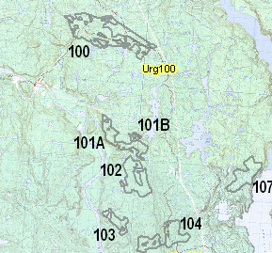

All these polygons will be treated by air and to increase the effectiveness of treatments, irrigation lines will be created out of the blocks and will guide the drivers that need to process the block. Each plane has a width of watering (swath is the English term) of its own (30 m, 50 m, 80 m or 100 m), we need to create a layer width of lines per irrigation for all blocks . The reason is that you never know what to spray block width will be treated until it is effectively treated. So they need quickly display a wide spray or other as needed.

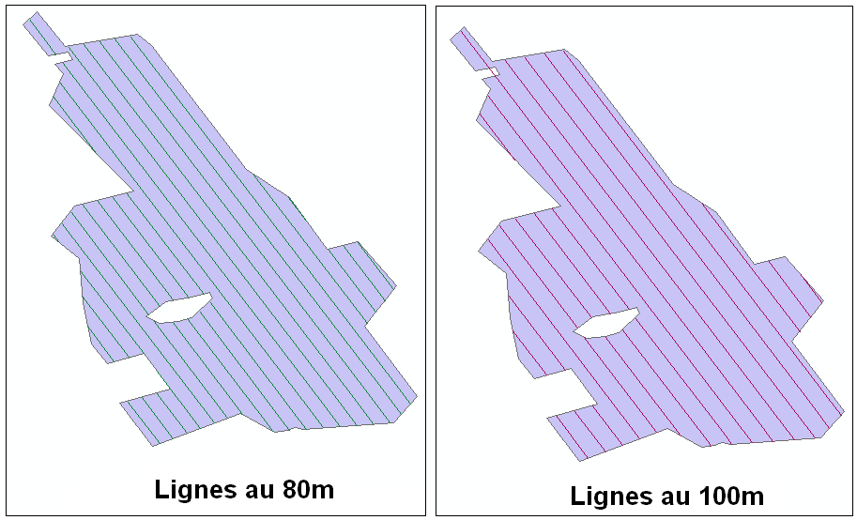

Also according to predetermined criteria, some blocks can be processed only once, while others will be twice (for different reasons, we could treat up to three times the same block). For example, a block where the population of pests is very high most likely require two treatments to effectively protect the species (trees). The number of applications necessary to protect a block is determined by the service records and this information is known: the prescription. SOPFIM therefore preparing these layers of information every year in January and February to be ready when the time comes to deal in June.

When that moment came in June, the role of the task group is to coordinate the processing of all these blocks using its fleet. To bring all this to happen, the operations manager must be able to quickly determine what needs to be treated and what are the priorities of treatment. This exercise is performed twice a day: once in the morning (3 h 30 AM) for the spray in the morning session and again in the afternoon (17 h) for the evening session. We need to know which block is open, which lines have not yet been processed and what is the priority treatment of these lines. A block is deemed to be open when the service records, using defined criteria, consider the block ready to be processed. The developmental stage of the insect, for example, is a criterion that affects the date of opening of a block.

On a daily basis, the Service provides records to the Operations Directorate a forecast date of opening for each block and possibly an effective date of commencement. The opening of blocks for different reasons, is not simultaneous: each block has its own forecast as well as opening its own effective opening date. When the block is open, the Service provides records to the Operations Directorate priority for treatment based on predetermined criteria (level of insect population, severity of damage to trees, etc..), All contained in a daily transmission called "Opening message." Using this information and knowing what lines have not yet been processed, the head of the Operations Directorate can send its fleet treating the appropriate lines.

**Description of visual tracking operations as used now**

Until now, the daily monitoring of treatments was performed using a large map taped to the wall where all the blocks were identified to deal with a number. In each of these blocks were printed lines watering. The width of these lines was watering the "expected" to treat each block. The head, after a session of spraying, "was coloring" the treated block and left intact the untreated portion. If a spray width different from that printed on the card was used for the treatment, the manager conducting the correspondence "in situ" widths between watering for "coloring" the good lines. If a second application was scheduled for a block, the head was coloring over the first application using a different color to distinguish the rows processed in the first and second application. This allowed to monitor the progress of work to do. For the first application, which was not painted was not treated and therefore remained to be done. For the second application, the colored lines by using the color "first application" were not treated in the second application and therefore remained to be done.

This method has its inconveniences, the first being the visual presence of more and more information as and as the program progresses. A map at the end of a program, is colored through and through and it can be easy to get lost. This requires the responsible extensive tracking information between messages it receives from the service opening statements and visual information that needs to update his map. On a printed map, we can not know if a block is opened or closed. We can not know the processing priority lines of this block. This is the opening message delivered daily by the service records and that the form of an Excel spreadsheet that provides this information.

An operational program is more extensive (high number of blocks to be processed), most treatment management becomes difficult. Overall coordination of all this information can also become tedious. For these reasons it would be appropriate to develop a computerized visual interface allowing us to quickly identify the rows to be processed and their processing priority, and without having to consult a table. Opening messages and reports of spraying should be able to affect the display of rows to be processed. The report is a daily spraying to identify lines that have been processed.

**Description of visual monitoring operations as desired**

The visual interface should be able to display (or not) the layers of information:

* All the lines of the program (by a layer width watering)
* All the lines open for treatment (a layer width by watering)
* All lines in anticipation of opening (width of a layer by watering)
* All operational units (outline of the block)
* All the experimental blocks (block outline)
* Sites of emergency release
* Operating bases
* The topographic base at 1: 50 000
  + Electrical network (powerline) (if available)
  + Forest Roads (+ Forestry Department if available)
  + Water layer

All previous layers, except the lines open for treatment and lines in anticipation of opening should be static: no updates through an entry form should not affect by these layers of information.

**All layer lines open for treatment**

The layer lines open to treatment should be updated by the Service records AND the Operations Directorate.

The Operations Directorate affects the display of lines by entering information about the rows processed: a processed row no longer appear (transparency). By cons, if a second application is required, these lines will appear again at the opening of the second application. The same principle applies if a third see a fourth application is necessary. The seizure of rows processed is done every day using the Report Form spray (this form is detailed below).

Service records affects the display of lines by entering information on the priorities of treatment and the opening lines. This entry is made daily using the Message form opening. Consult the 'Service records' of this document for details.

For displaying information, it was determined that a buffer would be applied to irrigation lines and that this information would be kept in a separate layer. A theme is applied to the layer to display the lines adequately and good color.

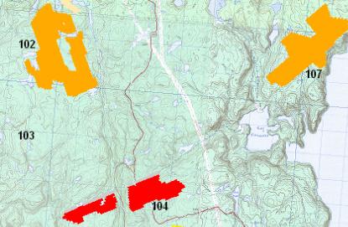

The thematic and applied to the "buffers" line displays the lines according to predetermined criteria. The color of the lines is determined by two conditions: treatment (yes, no, partial) and priority (must agree with the service records to identify the priorities and their effects). Priorities for the operational side, should indicate whether the block is open or not in addition to indicating the importance that the operations manager must be given to these lines.

For example

|  |  |  |  |
| --- | --- | --- | --- |
| Priority | Color | Line status | Weight to be given |
| 0 | Transparent | Closed | No |
| 0 | Color to be defined | Open | Normal |
| A |  | Open | High |
| 2 |  | Open | Moderate |
| 3 |  | Open | Low |

After treatment, the report should generate spray the following display:

|  |  |
| --- | --- |
| Processed row? | Color display |
| Yes | Transparent |
| Not | According to priority |
| Partial | Gray |

It is ultimately the combination of line status and priority that should condition the display.

|  |  |  |  |  |
| --- | --- | --- | --- | --- |
| Processed row? | Color | | | |
| Yes | Transparent (regardless of priority) | | | |
| Not | Priority 0 | Priority 1 | Priority 2 | Priority 3 |
| transparent |  |  |  |
| Partial | Priority 0 | Priority 1 | Priority 2 | Priority 3 |
| Transparent |  |  |  |

This way of displaying the information enables the operations manager a quick overview of what remains to be addressed. It does not have to worry about, visually, of what has been done or is not willing to do, but what remains now. The information on the screen is much lighter so it is easier to navigate. Several layers of information being available, he may, at its discretion, whether to display additional information.

|  |  |  |
| --- | --- | --- |
| **On the block, we see**:  -Watering lines numbered  -Contour of the block  -The remaining lines to be treated (gray and red) | **We see on the block:**  -Contour of the block  -The remaining lines to be treated (gray and red) | **We see on the block:**  -The lines that remain to be addressed  Gray = partial  Red = Priority 1 (High) |
|  | | |

The manager can change the zoom to get a broader picture of what lies ahead.

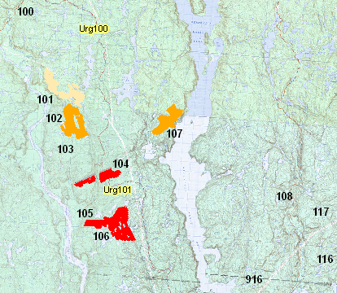

**Layer lines in anticipation of opening**

The operations manager would be able to display by selecting the layer lines in anticipation of opening lines of which the forecast date of opening is equal to the current date plus one day. The display color must be different (TBD) from those of treatment priorities, because the operations manager wants to be able to distinguish the lines in anticipation of opening those which are open.

It is for reasons of maximizing the return on the planes responsible wants to see the lines in anticipation of opening the next day. If lines are expected to be opened the next day and that a plane must now treat blocks in the vicinity of these lines and its load can be treated, why not treat them now and avoid the return on the block next day. It maximizes the time aircraft and use of insecticide.

**Additional visualization tools**

**Zoom tool** :

The operations manager would be able to quickly able to "zoom in" on a base of operations on a scale that allows it to have an overview of the blocks associated with this base. We would like to be able to define this "window" on a base of operations before the program began. Once defined, we should, by some mechanism (menu?), Can quickly reach this window.

**Behavior of layers of information**:

The head of operations that would, by default, layers of information selected during the last session are the same at the opening of the next session.

**Distance measuring tool:**

The head of operations would have access to a tool for measuring distance.

**Entries in the Operations Directorate: Report entry form spray**

Report spray form to enter data on the processing performed on the blocks to be processed. You can read the paper form currently used in Appendix 1.

The form for entering data might look like this:

|  |  |  |  |  |  |  |  |
| --- | --- | --- | --- | --- | --- | --- | --- |
| **YYYY / MM / DD** | **AM** | **PM** | **Spray** | | | | **BASE** |
|  |  |  | Yes |  | Not | Reason |  |

|  |  |  |  |  |  |  |  |  |  |
| --- | --- | --- | --- | --- | --- | --- | --- | --- | --- |
| **Block** | **Application** | **Swath** | **Product** | **Complete** | **Partial** | **Line** | **In Line** | **Individual line** | **Partial line** |
|  |  |  |  |  |  |  |  |  |  |
|  |  |  |  |  |  |  |  |  |  |
|  |  |  |  |  |  |  |  |  |  |
|  |  |  |  |  |  |  |  |  |  |
|  |  |  |  |  |  |  |  |  |  |
|  |  |  |  |  |  |  |  |  |  |
|  |  |  |  |  |  |  |  |  |  |
|  |  |  |  |  |  |  |  |  |  |
|  |  |  |  |  |  |  |  |  |  |
|  |  |  |  |  |  |  |  |  |  |
|  |  |  |  |  |  |  |  |  |  |
|  |  |  |  |  |  |  |  |  |  |
|  |  |  |  |  |  |  |  |  |  |
|  |  |  |  |  |  |  |  |  |  |
|  |  |  |  |  |  |  |  |  |  |
|  |  |  |  |  |  |  |  |  |  |
|  |  |  |  |  |  |  |  |  |  |
|  |  |  |  |  |  |  |  |  |  |
|  |  |  |  |  |  |  |  |  |  |

|  |  |  |
| --- | --- | --- |
| **Program volume** | **Cumulative amount sprayed** | **Percentage program conducted** |
|  |  |  |

Every day after the spray session in the morning, the information processing in the morning and the evening is entered using the entry form. This form is submitted that there was treatment or not. The significance of the information is as follows:

**­YYYY / MM / DD**: This field corresponds to the date of treatment and not to the current date. This field must be entered before the record is added.

**AM / PM:** this field, that could be called "period" is the period at which treatments were performed. Only two possible values ​​are: AM or PM and this value must be entered before the record is added.

**Spray**: This field indicates whether, on the date and time data, there were treatment (spraying) or not. The only two possible values ​​are yes or no.

**Base:** This field indicates from what basis were the treatments. A base is actually a base of operations: the place where planes take off when they go do their processing. Most often, this base is an airport. Entering this value should be done through a drop-down list containing all the operational bases of the control program. Because operational bases may change from one year to another, he should be possible to change the values ​​of this combo before the start of the program. We must be able to delete, edit or add bases. It should also be able to edit this list during the spray program to add or remove a base (if no records on this basis it has previously been entered, so you can remove a base of operations unnecessary.)

**The next section details of treatments. Several lines can be entered for a date, a period and a base of operations data. By cons, if the field spraying is not the value, it should not be able to enter treatment lines. And enter via a drop down list the possible reason for the non-treatment (no open block, fog, wind, rain, etc.)**

**Block:** This field contains the block number that has been processed. The value must be manually entered and validated before further entry. Must validate that the block number really exists in the table block operational contour, or in the table block experimental contour. This value must be entered before the record is added.

**Application:** This field contains the value of the application. To understand the concept of application, it should be understood that a block can be processed multiple times, according to specific criteria before the start of the program: number of insects present in the block state of degradation to protect trees, etc.. We must therefore include an application as a "layer" of spray on the block. Are we at our first product layer on the block, or the second? Usually, the blocks are treated in one or two applications, but it would be possible for various reasons, we come to three applications on a block. So they need to take this value with a combo which we can modify the contents before or during the program (3 to add an application, for example). This value must be entered before the record is added.

**Swath**: This field contains the value in meters from the effective spray width. The swath is the width of spray. Some aircraft have a width greater than spray other. Thus, an aircraft can spray with an effective spray width of 100 meters, while another will have an effective spray width of 30 meters. Until now, used spray widths are 30, 50, 80 and 100 meters. Should be able to take this value with a combo that can be modified as needed if new types of aircraft (with new spray widths) appeared on the market.

**Product:** This field contains the product name used when spraying. So they need to take this value with a combo that can be modified as needed if new products come to market.

**Full / Partial:** This field contains the status of the block. The block is it completed or partially processed? The state of the block must always be entered and it is the person in charge of operations who decide whether the block is completed or not. A block can be considered completed, even if all the lines were not treated. Once the block is considered completed, the lines of the block should no longer appear in the display interface of the Directorate of Operations until they reopen, if the block is never re-opened in the second application.

**Line:** This field contains information on a continuous interval of rows processed. If a value has been entered, you must also enter the value in the A Line to complete the range of lines. The two fields are linked. All there is between the lines From and including the last, are considered as treated (sprayed). So they need to take this value with a combo that will show the lines of the block concerned the spray width question (query on the table XXm flight line where the block = block recording XX = current and spray width of the current record).

**A Line**: This field contains information on a continuous range of rows processed. If a value has been entered, you must also enter the value in the Line for the complete range of lines. The two fields are linked. All there is between the lines From and including the last, are considered as treated (sprayed). So they need to take this value with a combo that will show the lines of the block concerned the spray width question (query on the table XXm flight line where the block = block recording XX = current and spray width of the current record).

**Individual line:** This field contains information on the treated individual lines, that is to say, not forming part of an interval of rows processed. We must enter this field a series of lines separated by a delimiter character (a ";" for example) and to be validated as "existing" for the block and spray width of the current record.

**Partial line:** This field contains information relating to the partially processed lines, that is to say, not having been completely processed. It's not often that several lines is partially treated at one sitting spray, but it should still be able to enter into this field a series of lines separated by a delimiter character (a ";" for example) and must be validated as "existing" for the block and spray width of the current record.

***The fields on the lines could also be treated in a single field in the form of a list of lines delimited by special characters. For example, a range of lines would be expressed by a dash boxes 2 line numbers (12-25), a single line by a line number one (8) by a partial line and a line number followed by a "%" (28%), all separated by ';'. Which would give the following result:***

***12-25, 8, 28%***

***Might be translated as "lines 12-25 and line 8 have been completed, and the line 28 has been partially treated.***

**Volume of the program:** This field contains the number of liters required to complete the entire spray program. This value is determined and entered manually by the operations manager (by default, this could be the same value as the previous report).

**Cumulative spray volume:** This field contains the number of gallons sprayed since the program began until the present report. She is determined and entered manually by the operations manager.

**Percent of program implemented:** This field should be a calculated field: Cumulative Volume sprayed / Volume = Percent Complete program.

**Implications of form input Report spray**

**Update of line conditions**

The capture of information processing must obviously affect the display of lines in the display interface. A line being processed should no longer be displayed, this implies the update of a field of all the layer lines open for treatment. The three possible values ​​for the line field can be treated: yes, no, partial.

A problem related to this update is the presence of multiple spray widths for the same block. No matter how wide the spray lines were treated, turn off all the overlapping lines. A treated area is an area treated, no matter how wide the spray used. Take, for example, a dummy block which has 8 lines with 30 meter lines 3 to 80 meters and 100 meters to 3 lines:

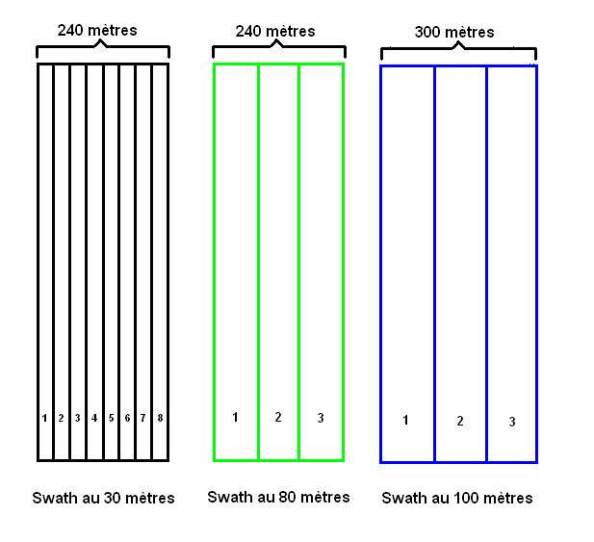

These spray widths are different representations of all spray width of the same block.

If a plane with a spray width of 30 meters treats the first three lines of block, one must also consider the equivalent line widths of the other treated as spray. In the following figure, gray lines are the lines in question dealt with the plane.

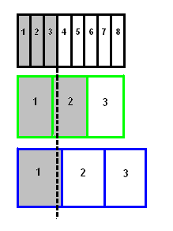

After treatment, it was agreed that all lines, regardless of the spray width, overlapping should be considered as treated. Is used to spray width which rows have been processed as a reference for updating the lines of the other spray widths. In the figure above, lines 1, 2 and 3 of the spray width to 30 meters have been processed.

As the third line to 30 m overlaps the second line to 80 m, line 2 to 80 m is considered, too, as treated.

The third line 30 m to not exceeding the limit of the first line in the 100, only the line 1 to 100 m treated is considered.

In the following example, all lines to 30 meters have been processed and we shall adjust the lines of other spray widths.

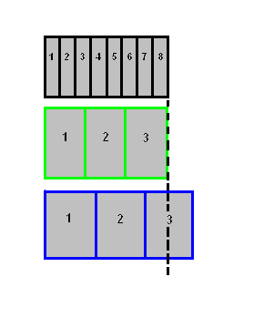

It is possible in the future, other types of aircraft with spray widths different from those we currently use are becoming commercially available. It would be important to think about a way to integrate these new layers of spray width (currently nonexistent) without having to revise the mechanism for updating the state lines. Can we make updates on a series of layers based on the layer name (or underlying table)? If all layers of spray width are named LignesBuffers_XXm (where XX is the spray width), can you update by replacing the "XX" by spray widths available?

Example of the logic proposed:

For a particular program, the aircraft available for spraying of spray have widths of 30 m, 50 m and 100 m. The information layer assembly lines open for treatment would theoretically composed of three layers of lines which will be called as an example:

LignesBuffers_30m

LignesBuffers_50m

LignesBuffers_100m

Can we update these layers using a loop?

|  |
| --- |
| Sun swath as table  **= All swath widths**spray used for this program thus: 30,50,100  For each swath  Update the display layer LignesBuffers_swathm  End |

We are open to discussion on the feasibility of the procedure or alternative solutions. The important thing is that the display is done properly for the user: the area consists of a set of rows processed should no longer appear in any spray width.

**Make available information Report spray for Service records**

The Chief, statements, when it prepares its "opening posts" must have access to data entered using the form Report spray. This information enables them to learn about treatments performed previously. The form in which this information must be available to be confirmed with service records. The choice of the form in which this information must be presented to Department records certainly influence the structure of the tables of the Report of spraying and can even change the way that will capture this information. We do not therefore speak of before table structure is clearly determined how the information should be presented to the Service records. We rely on the ESRI team to guide us in structuring tables say.

**Events to consider in the form of spray Report**

**The addition, modification** or deleting a record has implications for the data and the display of lines in the display interface. It is crucial to think through these implications, in order to properly structure the tables and their relationships. The implications are different depending on whether one chooses to represent the layer lines by spray width and treatment rather than spray width "only".

Example of layer by spray width only:

LignesBuffers_30m

LignesBuffers_50m

LignesBuffers_100m

Example of layers by spray width and application

LignesBuffers_30m_app1

LignesBuffers_30m_app2

LignesBuffers_50m_app1

LignesBuffers_50m_app2

LignesBuffers_100m_app1

LignesBuffers_100m_app2

The choice of representation implies a different treatment during the events to add, modify or delete the Report form the spray. For example, if we decide to represent the spray width lines by "only" and that modifies a record of a report before spraying early in the program, consider the data collected after the report before update the state of the row affected by the change. That is to say, if I change the status of a line being processed in the first application, I need to ensure it has not been addressed in the second application before you change its status to untreated. Separate the layers of information in width and spray application we would avoid this problem, but we would incur an additional layer of information. The advantages and disadvantages are evaluated. ESRI proposals on how to proceed will be appreciated ideal and carefully considered. It would therefore, ultimately, important to further reflection on the events of additions, changes and deletion of records on Form Report spray.

**Special case to consider regarding treatment priorities and applications**

It is crucial to be able to assign a priority to a line rather than an entire block. The reason is that the lines of the same block may be very different priorities and different applications. We have already explained that when the insect population of a block are very high, it is best to spray two product applications. The impact of the two applications is significant on the insect population. It was determined that when a block treated first application is completed, good practice is to open in second application seven days later. This is the way to the most effective in controlling insect populations.

Aerial spraying to be effective, depends on very specific meteorological factors: wind speed, precipitation, relative humidity, etc.. We understand that it is unnecessary to spray the product on a block of high wind days: one would not know or would eventually drop the product. These constraints are such that a spray block could be opened in the first and second application. Consider the following scenario:

Half the lines of a block are processed in the first application.

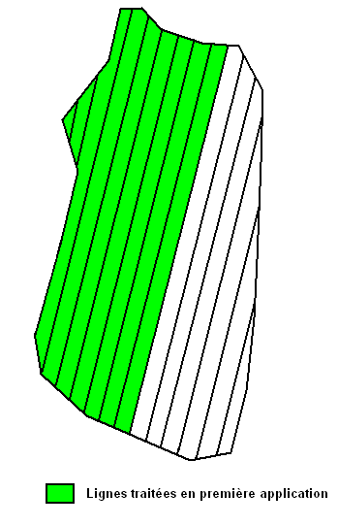

Now consider that for reasons of weather (rain, high winds), we can not continue spraying and aircraft have been grounded for seven days. When after seven days, the spraying conditions are met again, the block will be open at the first application and second application in part. The party has already been addressed in the second implementation is open and the party has not been addressed is open in the first application.

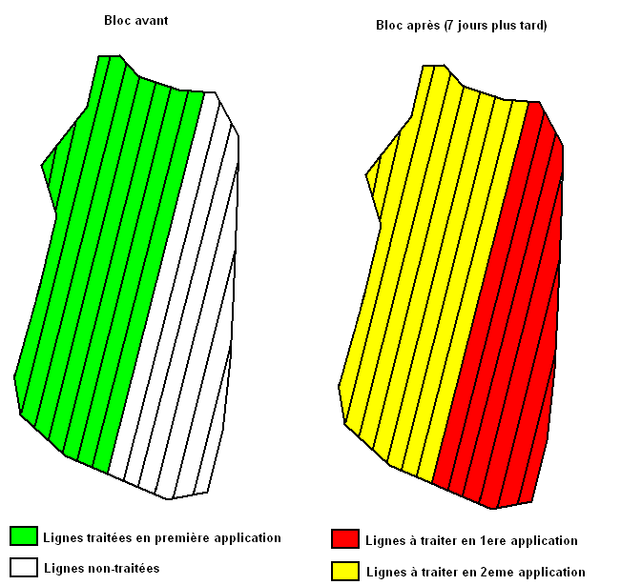

The previous example therefore illustrates a scenario where it would be possible to have two different applications on the same block. Priorities will also be, since the first application always overrides the second.

**Outputs of the Operations Directorate**

**Report Report spray**

**Opening Report Post**

The outputs required for the Operations Directorate are two reports that must be viewed onscreen and printed.

**Report Report spray**

This report shall contain the information entered using the form Report spray. The shape of this report is to be determined but will likely resemble the entry form.

**Opening Report Messages**

This report contains information captured by the Service records. The head of the Operations Directorate wishes to be able to consult the messages open. The operations manager did not want to see any information of a message of openness: it does refer to that information or open blocks in anticipation of opening the next day. The data to display yet to be determined. By default, the report should start with the most recent message, but still provide access to the above message. It is important that the date of the newest message is prominently displayed regardless of the display message: it permits the head of the Operations Directorate to quickly know when was the last update messages open. Opening messages could be presented in the form of an open read-only form through which you can navigate between the various messages. It is essential to be able to print a message to the user's choice. The form of the report remains to be determined, but should look to the form for entering a message of openness.